MEMORY HYPERTEXT

A 2-player cooperative game that uses memory to solve mystery.

# Abstract:

Memory Hypertext is created by Suyi Diao in Game Design 1 class in Fall 2018. It is a game where 2 players act as detectives and cooperatively try to solve a mystery using the main mechanics of the game Memory. The mystery is written in such a style that certain words or phrases are linked to the symbol in detectives’ memory which will provide more clues if recovered. Then recovered clues will contain more such words or phrases. Even though the game is highly cooperative as each detective only functions 50% in the process of memory discovery, each detective is going to give his/her own answer in the end as they are also rivalry at the same time.

# Material List:

* One set of Eyegamer’s card.
* Several sets of written mystery index cards.

# Rules:

* At the start of the game, 2 players decide which set of mystery index cards they want to play, each set contains one mystery that needs to be solved.
* After choosing, the index cards set will be brought to them facing down, they need to flip up the top one that says “Mystery” on the back and put it in the “Known Clue” zone.
* Besides the top one and the bottom one, each index card is drawn with an Eyegamer image on its back. Players need to pick out all the pairs of Eyegamer cards that match the images, shuffle them, and put them randomly on a grid. The size of the grid will be randomly decided by players.
* 2 players then take turns to flip up 1 Eyegamer cards facing down. If 2 facing up Eyegamer cards’ images are identical, then: If the image matches one of the clues on one of the index cards in the “Known Clue” Zone, flip the index cards which has the same image on the back, put it in the “Known Clue” Zone, put the identical Eyegamer cards in the trash pile, and flip back all Eyegamer cards that are facing up; If the image does not match any clue, then flip back all Eyegamer cards that are facing up.
* If the number of clues (“Mystery” not included) in the “Know Clue” zone exceeds the constraint number (which can be found on the back of “Mystery card”), then each player needs to come up with a solution to the mystery on the Mystery Index card. If one player says: “I know the answer” before it happens, each player needs to come up with a solution right away. After stating the answer, 2 players reveal the index card that has word “Answer” on its back. The amount of winner in the game is equal to the number of players that has a solution equal to the “Answer”. There can be 2, 1, or 0 winners after each game.

# Images:

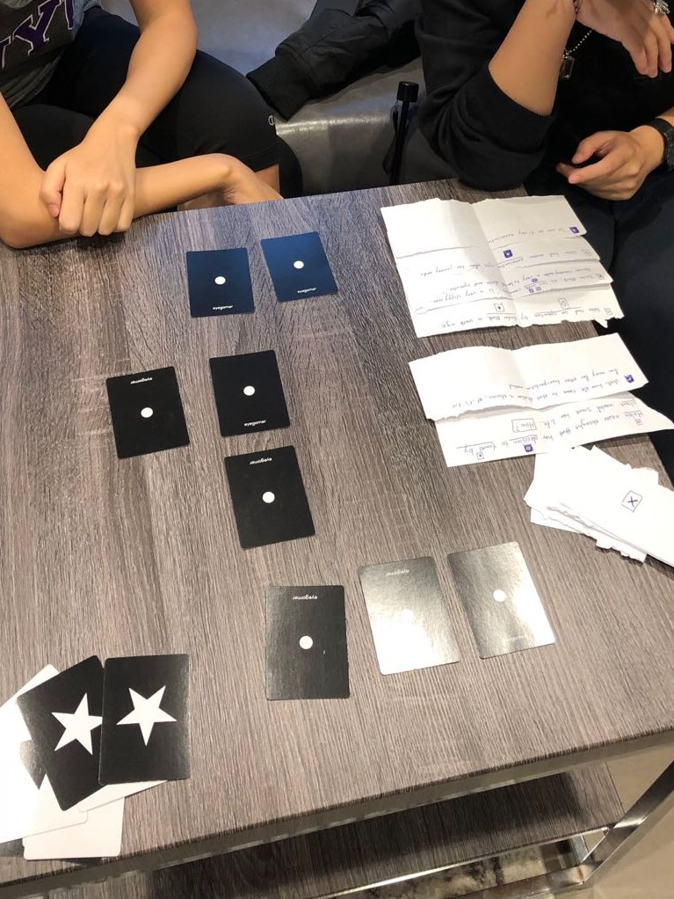

# Design Process Statement:

Some of the first problems I noticed about the original game Memory are: It was painful to flip cards back and force; It was hard, if not impossible, to remember abstract geometric shapes; The experience of the game did not change at all when changing from playing alone to 2 players; And no strategy is involved in the game, which is fine but I personally hate.

It was easy enough to solve the first two problems by adding the rule where 2 players take turns to flip one up and reducing the number of the cards by half. This way players don’t need to flip cards back and they can remember things better as the time cards facing up increases significantly.

However, not only new problems occur after the change, but also solving the last two problems is as hard as it can be. During playtest Thursday, I played as many games as possible and it helped me greatly. From Dan’s initial twitch on UNO and the Killer Queen, I see adding multiple objectives in the game can effectively add strategic depths. From Runyu’s and Yuxin’s initial twitch on Memory I see how the greater a player’s action can influence (sabotage mostly) the opponent, the stronger the feeling of conflict the game elicits. However, in my game if a player makes a move, it will either: greatly annoy the opponent (find a pair), greatly disappoint himself/herself (not finding a pair), or greatly disappoint everyone (calls to end turn and flip all cards back). It became press-your-luck type of game but the reward for pressing your luck is too small (only gain one pair) and the punishment is too great (flipping all cards back). Also, some of the crucial old problems are not solved. It was still too hard to memorize the card, even though the time cards stayed flipped up increases significantly. Since I could not change the image on the card, which, I believe, is the cause of the problem, I went on the other way. I tried to make the players focus on remembering only one image at a time together. By changing to this direction, I completely changed my game from competitive to cooperative. And this solution also solves the first three of my problems. By having the clues in the narrative spilt apart, I solved the strategy problem.

As of today, I am still making more sets of mystery. This is the final problem I need to solve. Players can only play one set of mystery once as they will know the answer in the end. So, I need to write up more and more mysteries to keep players playing.